Project Development APT – Phase 2

Course: Capstone – PT4614

Team Members:
Matías Contreras
Danae Ugarte
Elías López

Degree Program: Ingeniería informática.
Campus: San Joaquín
Date: 11-10-2025.

Table of Contents
1. Adjust the proposal considering challenges, enablers, and feedback.
- Adjustment and Risk Mitigation Strategy.

2. Relevant Work Methodology.
- Scrum Application and Rubric Alignment.
- Detailed Sprint Structure.

3. Project Progress Evidence.

1. Adjustments to the Proposal
The initial proposal is solid and well aligned with the objectives of the Capstone project, but it is crucial to implement adjustments to mitigate risks and ensure success within the 18-week timeframe, maximizing the use of available facilitators.
Adjustment and Risk Mitigation Strategies
The adjustments focus on the feasibility factors identified in Phase 1.
This strategy addresses point 1 of the rubric and proposes modifications to the APT project, taking into account difficulties, facilitators, and feedback.

 | Category | Adjustment Strategy | Justification/Benefit
 | Limited availability of information from the Community Board | Obstacle |  | Prioritize Sprint 0:  Ensure a kickoff meeting with the Community Board during the first week to validate and document 100% of the functional and non-functional requirements. | Minimizes the risk of delays at the start of the project and allows for the creation of a complete backlog, meeting the defined project scope.
 | Team schedule coordination | Obstacle | Standardize communication:  Implement 15-minute Daily Scrum meetings at a fixed time and use a single tracking tool. | Improves coordination and teamwork, which are essential elements for meeting rubric standards.
 | Access to real information from a Community Board | Facilitator |  | User acceptance testing with real users:  Include validation of prototype mockups and the functional system with actual members of the Community Board. | Ensures usability and guarantees that the solution has a positive impact on the community, aligning with the project’s objectives.
 | Free tools available (e.g., VS Code, MySQL, GitHub) | Facilitator |  | Definition of stack and environment:  Standardize framework and language versions and configure the GitHub repository for immediate collaborative work | Optimizes C4 software production and ensures that all evidence is properly stored in GitHub.

2. Relevant Work Methodology
The Scrum methodology will be used due to its agile approach, flexibility, and ability to deliver functional value in short cycles (Sprints). This is consistent with the disciplinary requirements of Computer Engineering (C2 – manages IT projects).

Scrum Application and Alignment with the Rubric
This methodology enables the achievement of the proposed objective (General Objective: to develop a responsive web system) and meets point 2 of the rubric by applying a methodology that supports the accomplishment of the goal according to established standards.
Scrum Component | Defined Structure/Roles | Requirement
Development Cycle | Two-week Sprint | Rubric 2: Achievement of objectives using a standard methodology.
Key Roles |  | Elías López – defines and prioritizes the backlog.  Scrum Master:  Matías Contreras – facilitates the process.  Developers:  Danae Ugarte, Matías Contreras, and Elías Lopez. | Rubrics 7 and 8: Demonstrated teamwork, equal participation, and subject knowledge.
Work Planning |  | Detailed Work Plan:  The plan is divided into tasks associated with competencies C1, C2, C3, and C4, ensuring full coverage of the specific objective. | Rubrics 3 and 6: Activities must generate evidence that aligns with planning and meets established standards

Detailed Sprint Structure
The Sprint sequence is coherent and ensures the integration of the graduation competencies (C1 to C4).
Sprint | Durationn | Main Focus | Applied Competencies | Generated Evidence
0 | 1 week | Requirements gathering and planning | C2 (planning) | Requirements gathering report
1-2 | 4 weeks | Database desing and backend development | C3 Data modeling,  C4 Business logic | Data model and architecture diagrams
2-3 | 4 weeks | Frontend development and functional prototype | C4 User interface | User interface prototype mockups
4 | 2 weeks | Integration and testing | C1 Certification testing | Testing and validation
Final | 1-2 weeks | Documentation and presentation | C5 Documentation | User manual, technical documentation, and final presentation

3. Project Evidence
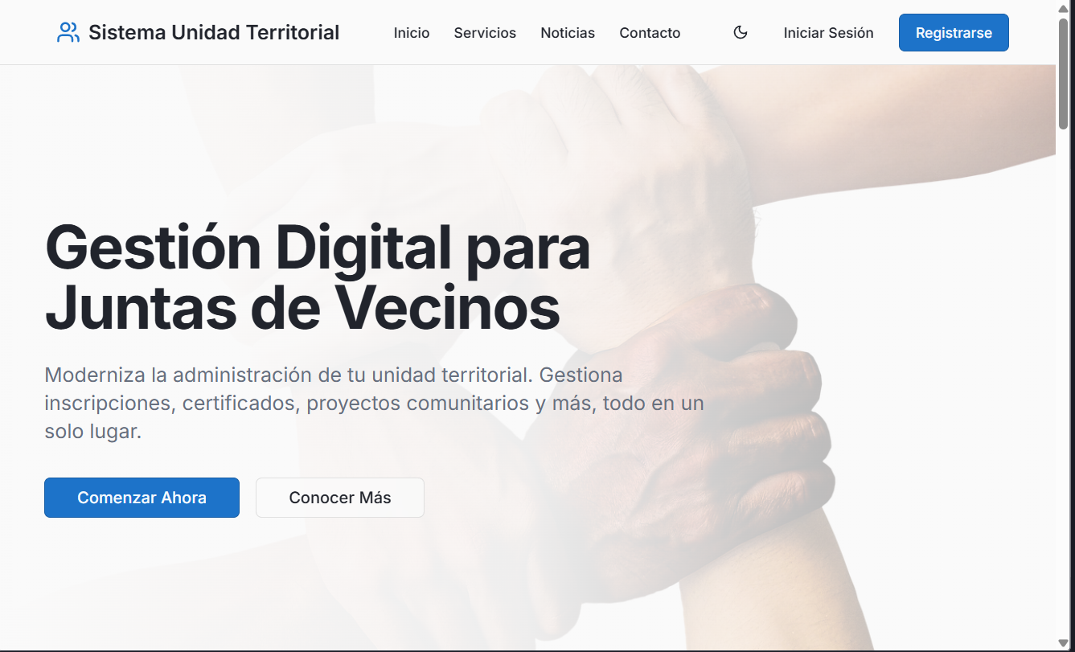
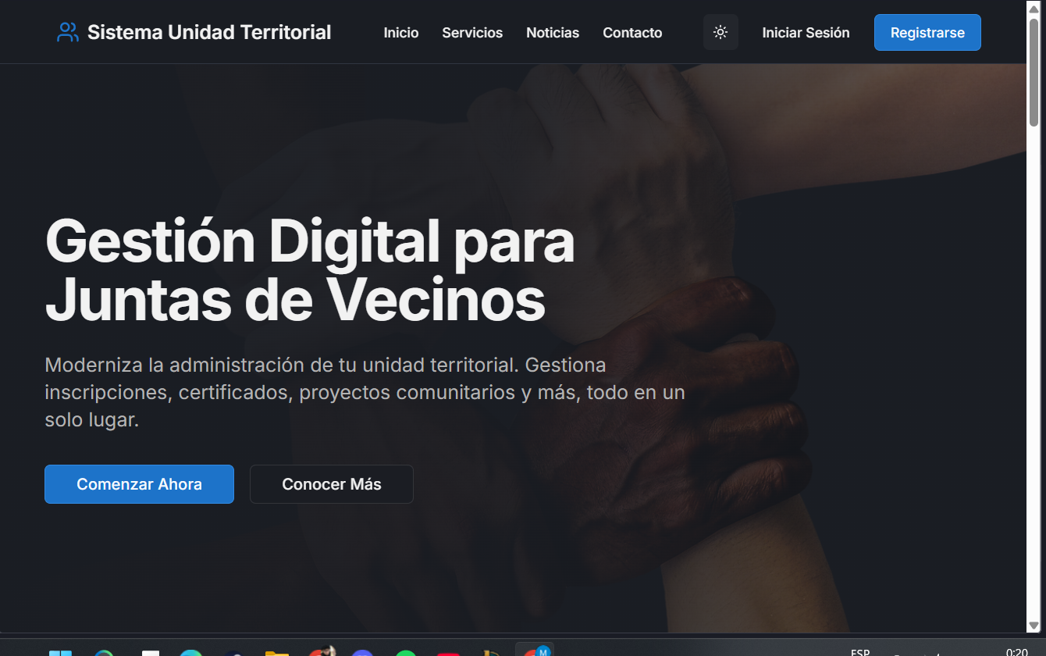
Displays the main navigation menu with access to Home, Services, News, Contacts, and more — including a dark mode option.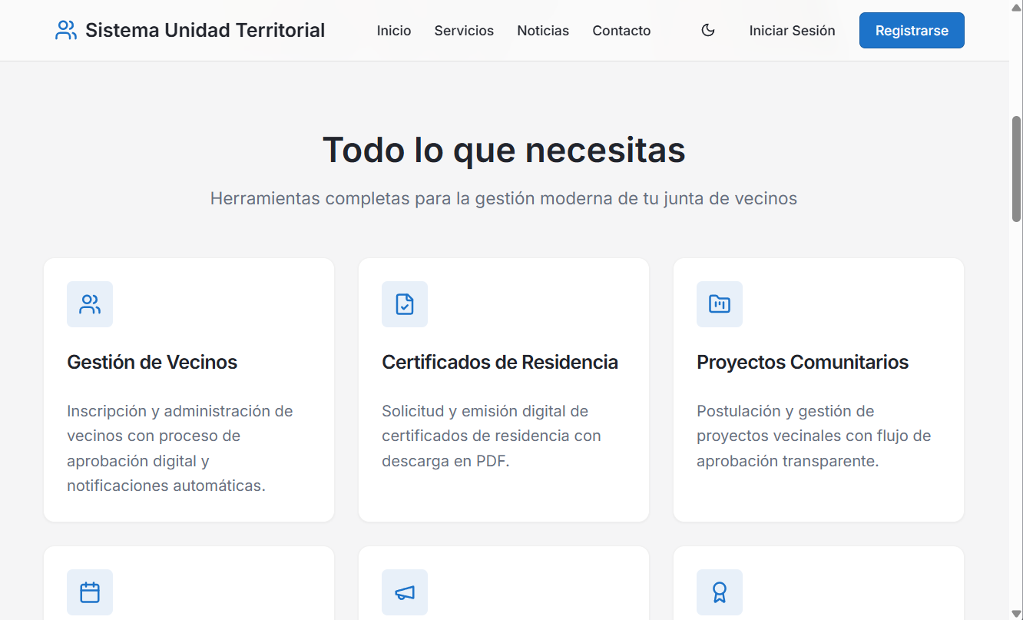
It details the main functionalities offered by the software; our goal is to show the user “Everything they need” for modern and efficient management.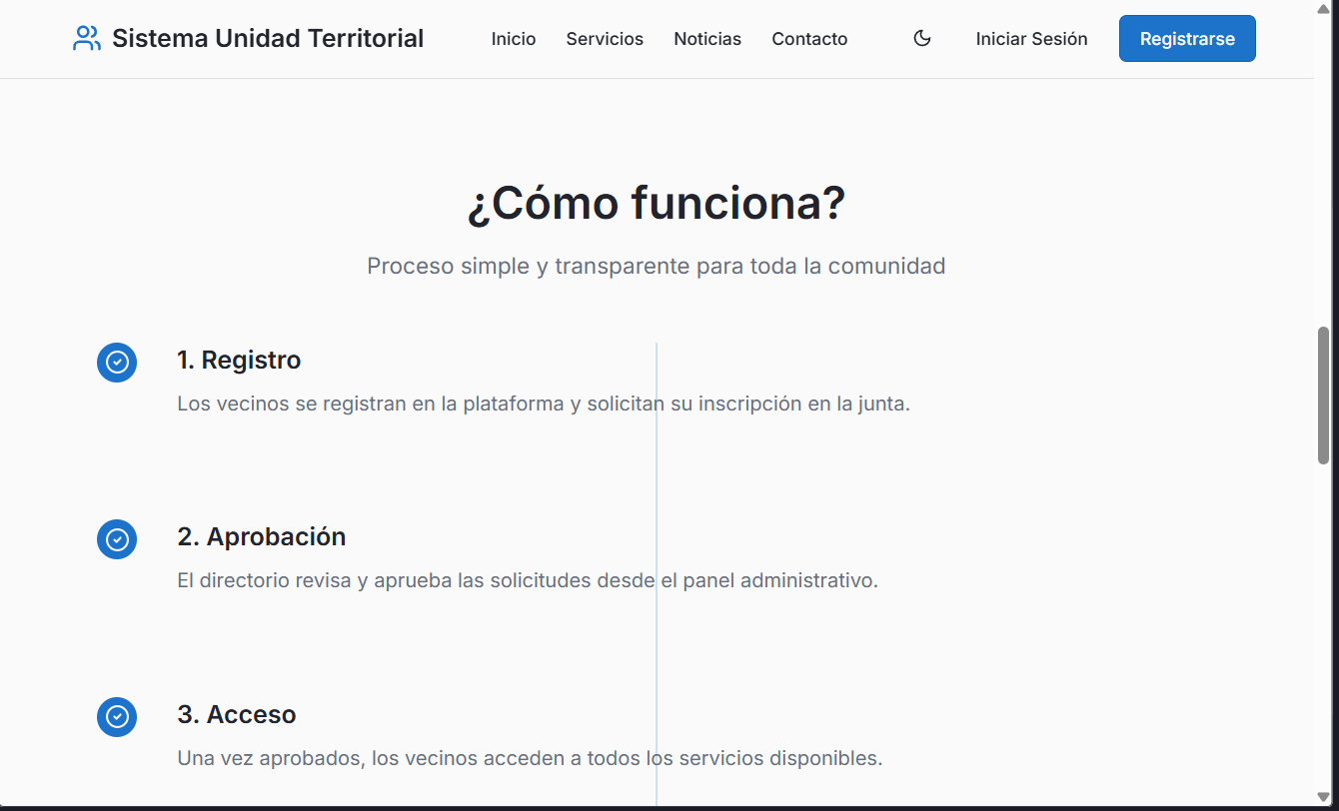
This section clearly explains the process that a community member must follow to become an active user and how to manage their registration within the system.

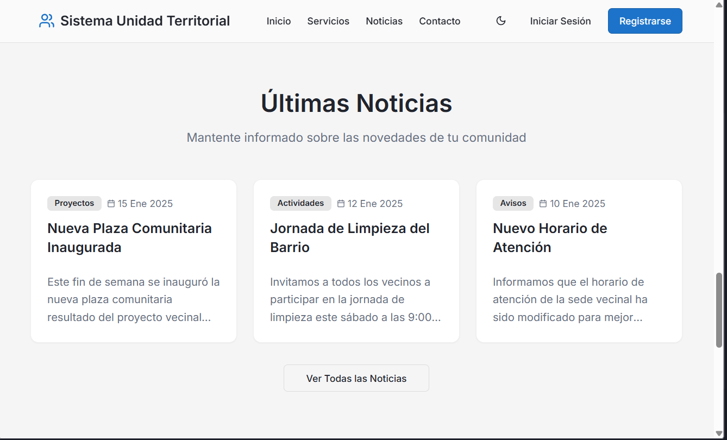
This page represents the key functionality aimed at improving communication between the neighborhood council and its members.

